The Episcopal Diocese of Northern California
1

THE EPISCOPAL DIOCESE OF NORTHERN CALIFORNIA REGIONAL DISCERNMENT GUIDELINES
With gratitude, we acknowledge and thank the Episcopal Diocese of El Camino Real, the Wingfield Deanery, The Reverend Canon Cookie Clark, and The Reverend Susan Reeve, The Reverend Babs Haggenjos for their generous contributions of time and wisdom in laying the foundation for these guidelines.
We also extend our thanks to The Reverend Dr. Anny Genato, Linda Maxwell, Mary Circle, and Susan Wahlstrom for their significant contributions to the continued development and refinement of these guidelines.

September 2025

DIOCESE OF NORTHERN CALIFORNIA RDG INFORMATION AND TRAINING MANUAL

MAKE UP AND ROLE OF AN RDG TEAM………………………………………………………….PAGE 3-4
FUNCTION OF A REGIONAL DISCERNMENT GROUP TEAM…………………………………….PAGE 5
THE SUGGESTED RDG MEETING SCHEDULE………………………………………………………….PAGE 5
WHAT IS DISCERNMENT……………………………………………………………………………….PAGE 6
RDG TEAM MEETINGS…………………………………………………………………………………..PAGE 7
ORDINATION CANDIDATE IDEAL QUALITIES…………………………………………………PAGE 8
PROCEDURAL GUIDELINES…………………………………………………………………………….PAGE 9

MINISTRY AND LEADERSHIP IN THE EPISCOPAL CHURCH……………………………PAGE 10

ORDERS OF MINISTRY………………………………………………………………………………….PAGE 11
ORDINATION PATHS………………………………………………………………………………………PAGE 12-13
SUGGESTED MEETING AGENDAS…………………………………………………………………...PAGE 14-20
OUTLINE OF THE RDG FINAL REPORT……………………………………………………………PAGE 21
LETTER TO DISCERNER AFTER RDG………………………………………………………….………PAGE 23
BEST PRACTICES FOR DISCERNMENT……………………………………………………………APPENDIX A
BCP ORDINATION VOWS………………………………………………………………………………….APPENDIX B
AUTHORIZED TRAINERS……………………………………………………………………………….APPENDIX C

THE MAKE-UP OF A REGIONAL DISCERNMENT GROUP (RDG) TEAM
- An RDG consists of four people—both lay and ordained—from various congregations in the Diocese of Northern California
- The four roles on an RDG are: Facilitator, Recorder, Chaplain, and Scheduler

Composition of the Team
- Each RDG must include:
  - At least one member from the discerner’s home parish (who knows the discerner)
  - At least one clergy person
  - At least one lay person
- Ideally, but not necessarily, RDG members are from the discerner’s deanery
- Up to two members of the team may come from the discerner’s home parish

Forming the Team
- The Facilitator is trained by a Commission on Ministry (COM)–authorized RDG trainer/coordinator
- The Facilitator recruits three additional members. If assistance is needed in identifying members, the COM RDG coordinator should be consulted
- One of the recruited members must come from the discerner’s home parish

Time Commitment
- An RDG usually meets nine (9) times over a period of four to six months
- Meetings occur every 1–3 weeks and last approximately 1 hour with the discerner plus 20 minutes for team organization

Meeting Format
- RDGs may meet either in person or via Zoom
- The mode of meeting should take into account driving distance, meeting space availability, technical ability, and internet access
- For Zoom meetings, all participants must have reliable internet, fully charged device, and a computer with video and audio capability
- Ideally, if the team meets over Zoom, it would be good to have the first meeting in person

The Diocese Zoom account is available; inquire with the RDG Coordinator for access

Roles and Responsibilities
Facilitator
- Receives training from the COM trainer
- Recruits team members
- Leads RDG meetings, ensures the agenda is followed, and begins and ends on time
- Ensures that difficult questions are addressed with compassion and openness
- Communicates with the COM trainer/coordinator
- Arranges for a replacement if unable to attend a meeting
Recorder
- Takes notes during meetings to support the group’s reflection and the preparation of the final report
- Sends the notes to the team members after the meeting
- Ensures notes are destroyed once the final report is submitted
- Individual members may also keep personal notes for their own use between meetings
Scheduler
- Coordinates meeting dates, times, and locations (or Zoom links) that work best for the team and the discerner
- Receives Zoom log-in information from the RDG Coordinator
- Sends reminders of meeting details the day before each gathering
Chaplain
- Opens each meeting with prayer or a spiritual reflection
- May draw from prayers in the Book of Common Prayer (pp. 810–841) or other appropriate sources

FUNCTION OF A REGIONAL DISCERNMENT GROUP TEAM

- The first meeting is devoted to information distribution, training and organization. After the first meeting, the dates, time and location of the remaining meetings are determined by the team and the discerner. The time commitment involves seven meetings with the discerner, the initial training and organization meeting, several team evaluation discussions before or after a meeting with the discerner, a meeting to assemble and prepare the final report, and finally, a meeting with the discerner to discuss the RDG’s recommendations

- The final report is sent to Jacqi Seppi at jacqi@norcalepiscopal.org

- The ultimate goal of the RDG is to produce a Final Report
    - The Report is sent to these parties:
      - the discerner’s home parish’s Vestry/Mission Committee,
      - the Bishop,
      - and the Discernment Weekend Participants (the Commission on Ministry and the Standing Committee)

- The final report remains confidential

The Suggested RDG Meeting Schedule

Session Topic: Participants:
  - Initial Organization and Training Review RDG Coordinator/RDG Team
  - Introduction and Spiritual Journey RDG Team/Discerner
  - Spiritual Life and Prayer RDG Team/Discerner
  - Their Call to Ministry RDG Team/Discerner
  - Family Life and Self Care RDG Team/Discerner
  - Leadership and Ecclesiology RDG Team/Discerner
  - Academic and Intellectual Life RDG Team/Discerner
  - Preliminary Drafting of RDG Team Report RDG Team
  - Review of the Final Report RDG Team/R/V/P-I-C/Discerner A detailed outline of the suggested Meeting Agenda will be presented in a later section.

WHAT IS DISCERNMENT

“In classical spirituality, discernment means identifying what spirit is at work in a situation: the
Spirit of God or some other spirit.”

(Suzanne G. Farnham, Joseph P. Gill, R. Taylor McLean, and Susan M. Ward, Listening Hearts: Discerning Call in Community, rev. ed. (Harrisburg, PA: Morehouse Publishing, 2002), p. 23).

What does discernment involve? A dictionary would tell you that "to discern" means "to recognize" or "perceive." What is done in an RDG Team is to attempt to discern - to recognize or perceive - the will of God for the Church and for the discerner. Attempting to discern the will of God is risky and bold - just as saying the Lord's Prayer is "bold." Therefore, discernment is, and should be, an exercise in prayer, careful listening or attentiveness, and patience. In discernment we are listening and waiting to gain clarity about the nature of a particular person's calling from God.

- Discernment is more than just a skill. Discernment is a gift from God before it is anything else. Yet there are clearly skills you can put to use when using your gift, and you can become better at it through training and experience.

- Discernment is more than just a process. Even for the most “material” or “nitty-gritty” matters, there is a Spirit at work nudging us, leading us, and even pulling us. Then again, even for the most “spiritual” matters, there are disciplines, methods, processes, means, and tools, which the Spirit can work through to help us discern rightly. Discernment isn't usually a sudden zap from beyond, but something which emerges from hard work and close attention.

Recommended reading:

Listening Hearts: Discerning Call in Community
(Suzanne G. Farnham, Joseph P. Gill, R. Taylor McLean, and Susan M. Ward, rev. ed. (Harrisburg, PA: Morehouse Publishing, 2002).

Grounded in God: Listening Hearts Discernment for Group Deliberations
Suzanne G. Farnham, Stephanie A. Hull, and R. Taylor McLean, rev. ed. (Harrisburg, PA: Morehouse Publishing, 1999).

Pursuing God's Will Together: A Discernment Practice for Leadership Groups
Ruth Haley Barton (IVP Books, 2012).

RDG TEAM MEETINGS

The Charge given to the RDG

The RDG Team is only one of several groups and many individuals that have been, and will be, discerning on behalf of the Church and the discerner. The RDG Team will work with the discerner to help discern God’s call through discussions, prayer and the guidance of the Holy Spirit. In what way is God calling this person to ministry? What potential can be seen? A final report will be prepared by the team and will contain a recommendation that the discerner either continue in the process of discerning a call to ordained ministry or continue serving God and the Church through baptismal ministry. Also, if anything about the discerner has been identified as an area of concern and would possibly benefit the discerner through additional formation, it should be indicated in the report as well.

INTRODUCTION

We uphold these values when discerning a call to ordained ministry:
- God calls people both by inward spiritual experience and by the outward beckoning of the community, the body of Christ
- Our process of discerning various calls to ministry is rooted in the history, doctrine, community, and worship of the Episcopal Church
- Each individual is treasured and held in the highest esteem
- Baptism calls each person to ministry
- All orders of ministry—laity, religious life, deacons, priests, and bishops—are equally important in carrying out the mission and ministry of Christ’s Church
- In the discernment process we are to be prayerful, centered in God, patient and yearning for gracious guidance
- Conversations concerning discernment are always to be open, honest, and confidential
- Thorough evaluations and recommendations from sponsoring clergy and vestries/mission committees are essential and vital

ORDINATION CANDIDATE IDEAL QUALITIES
We look for these qualities in persons seeking ordination and recognize that this is a long list and many of these qualities may still be developing:
- A deep commitment to follow Jesus Christ as Savior and Lord
- A desire to seek God’s will
- A love of Jesus Christ that can inspire and empower others
- A practice of prayerfulness and servanthood demonstrating durable Christian faith and witness
- A significant leadership involvement in church activities
- Involvement in and a keen awareness of the issues of society
- The ability to integrate the needs of the world with the message of the Gospel—a quality especially important for a deacon
- Commitment to the development of moral character patterned after the life of Christ
- A capacity for perseverance in difficulty, a resilience in adversity, and an ability in using life experiences as vehicles for personal growth
- Intelligence and imagination with a sound educational background
- The ability to learn and a desire to continue to learn
- The ability to communicate well
- The ability to teach and to give a reasoned account of the Gospel
- A desire to help others grow in faith and knowledge
- A commitment to listen with sensitivity and understanding
- The ability to hear and accept constructive criticism
- Initiative and energy; the capacity to be a self-starter and to work hard
- A sense of humor and humility
- Self-awareness, including a firm grasp of one’s personal strengths and weaknesses
- A healthy sense of personal and institutional boundaries
- The ability to care for and serve others and to be with them in times of crisis
- An enjoyment of others; pleasure in human interaction, and a history of getting along well with others and cooperating in team efforts
- Breadth of vision and acceptance of others; an ability to relate to people of different personalities and ages and from varying religious, cultural, and economic backgrounds
- A demonstrable ability to be a leader, to motivate and enable the ministry of others, and to be an agent of change

SOME PROCEDURAL GUIDELINES
The process you are entering as a group is a delicate one and as a result, each RDG Team will probably be different. The following suggestions are meant to help in the formulation of the path to be taken when interacting with and helping your discerner in his or her discernment.
- A meeting should begin with some quiet time for centering and freeing yourselves of the worries of the world
- Always open each meeting with a prayer. Several relevant prayers can be found in the BCP on pages 810-841
- Some form of Bible study, Lectio Divina or other prayer should be used at the beginning of each meeting. This could entail some form of Bible, such as lectio divina and should be used at the beginning of each meeting. Suggested passages are: 1 Corinthians 12: 1, 4-14: Ephesians
4: 7, 11-16: Romans 12: 1-8: and Acts 4: 1-13
- All must be involved in the discussions. Although your work is primarily focused on the discerner, members of the team should offer abbreviated comments of similar experiences in support of the discerner. Involvement by the team will reduce the feeling of an inquisition for the discerner
- An absolute requirement is that this entire process is confidential. “What occurs in an RDG meeting stays in the RDG meeting.” The only sharing occurs as the result of the distribution of the final report. The rector/vicar/priest-in-charge of the sponsoring congregation receives a copy of the final report and it is up to them whether to share the report with the Vestry. The reports sent to the Commission on Ministry and the Bishop are held in the strictest confidence
- All questions should be informational and as open, honest and straightforward as possible. This means no giving advice, no “why don’t you?” or “here is how I would do it.” No personal agendas should be involved at all
- Trust in yourself and ask questions that may be odd but meaningful to you. “What shape or color is your present vocation and what is the one you are discerning?” Why?
- Don’t be in a hurry. Your time together should be relaxed and gentle. Leave time between questions for reflection. Don’t be afraid of silence. Silence may mean something important is happening or is going to happen—don’t rush to fill the silence
- Practice active listening whenever possible. Listen with your entire self (senses, feelings, intuition, imagination, and all of the other rational faculties)
- Speak only for yourself and don’t interrupt. Do not formulate what you want to say while someone else is speaking. Don’t speak in broad generalizations. Don’t challenge what others say
- Honor the positives and accept the negatives. The discerner will succeed in his/her vocation because of what he/she does well and not because of what she/he doesn’t do well. Support and encourage positive behavior of the team as well as the discerner

Always close the meeting with a prayer.

MINISTRY AND LEADERSHIP IN THE EPISCOPAL CHURCH
Discerning a call to ordination is a sacred and courageous step. It reflects both humility before God and a deep love for Christ’s Church. Yet before we speak of ordination, we must speak of ministry itself.
The Episcopal Church teaches that ministry is not the property of the ordained but the vocation of all the baptized. At baptism, every Christian is joined to Christ, the great High Priest, and becomes part of the “royal priesthood” described in 1 Peter 2:9. Through him, the Trinity calls and equips each believer to serve as a priest in the world—bearing witness, serving in love, and working for reconciliation.
The Catechism expresses it clearly:
“The ministry of lay persons is to represent Christ and his Church; to bear witness to him wherever they may be; and, according to the gifts given them, to carry on Christ’s work of reconciliation in the world; and to take their place in the life, worship, and governance of the Church.”
This is the foundation: all Christians are ministers of Christ.

Ordination as Leadership
Ordination does not grant ministry; it sets apart certain persons for leadership within the Body of Christ. As Ephesians 4 teaches, Christ gave apostles, prophets, evangelists, pastors, and teachers “to equip the saints for the work of ministry, for building up the body of Christ.”
Ordained ministry is therefore a particular role: to lead, to shepherd, to teach, to administer the sacraments, and above all, to equip others for their own ministries. Clergy serve not above the priesthood of all believers, but within it, providing order, guidance, and vision so that the whole Church may flourish.
God’s mission is the redemption and renewal of the world, and all of humanity is invited to participate. Every believer has a role—sometimes public, sometimes hidden, but always holy—in embodying and sharing God’s love.
Thus, the central question in discernment is not “Am I called to ministry?”—for you already are. The question is, “Am I called to leadership within the Church, for the sake of equipping others in their ministry?”

Walking Together in Discernment
For discerners, the work of discernment is to listen deeply to God’s call: is it to the life-giving work of lay ministry, or is God setting you apart for leadership within one of the ordained orders? For RDG members, the work is to accompany, encourage, and help clarify this call, always remembering that every baptized person is already a minister of Christ.
In whatever way the Spirit leads, may this discernment strengthen your sense of belonging to Christ’s royal priesthood and deepen your joy in the holy work of redemption.

THE ORDERS OF MINISTRY
The Episcopal Church recognizes four orders of ministry, each building upon the other: laity, deacons, priests, and bishops. All are rooted in baptism, and each has unique responsibilities.

The Ministry of the Laity
- To live as the image of God (imago Dei)
- To represent Christ to the world
- To use one’s gifts for the greater good
- To work for reconciliation with God and neighbor
- To participate in the life, worship, service, and governance of the Church

The Ministry of Deacons
- To lead God’s people in service to those in need
- To interpret the needs, hopes, and concerns of the world to the Church
- To embody servant ministry at the threshold between Church and world
- To proclaim and preach the Gospel
- To assist priests in the sacraments

The Ministry of Priests
- To serve as visionary leaders in the Church
- To preach and proclaim the Gospel
- To administer the sacraments
- To bless the people
- To declare God’s forgiveness through Christ
- To share in the oversight of the Church’s mission with the bishop

The Ministry of Bishops
- To serve as the chief pastor and leader of a diocese
- To guard and teach the faith of the Church
- To ordain new leaders into the Church’s ministry
- To represent the unity of the Church in apostolic succession

Alongside the four orders of ministry, the Episcopal Church also recognizes the witness of Religious Orders and Christian Communities, both traditional and new expressions. These communities are not a separate order of ministry but a distinct vocation rooted in baptismal identity. Members—lay or ordained—take vows or make commitments to live according to a shared rule of life.

The Ministry of Religious Communities
- To live a life of prayer, discipline, and mutual accountability
- To embody the call to simplicity, service, and hospitality
- To witness to the values of the Kingdom of God through communal life
- To support the wider Church through intercession, teaching, and service
- To explore innovative forms of community and mission in contemporary contexts
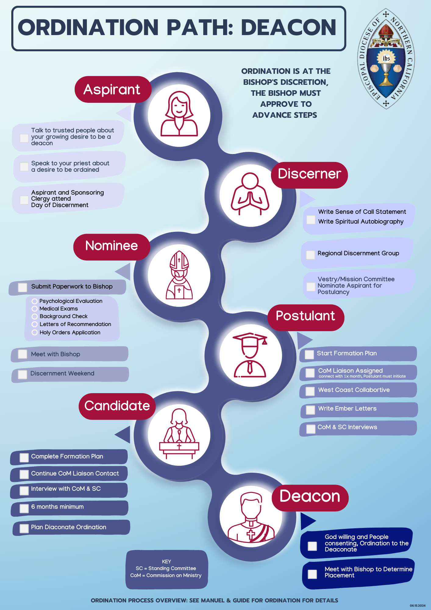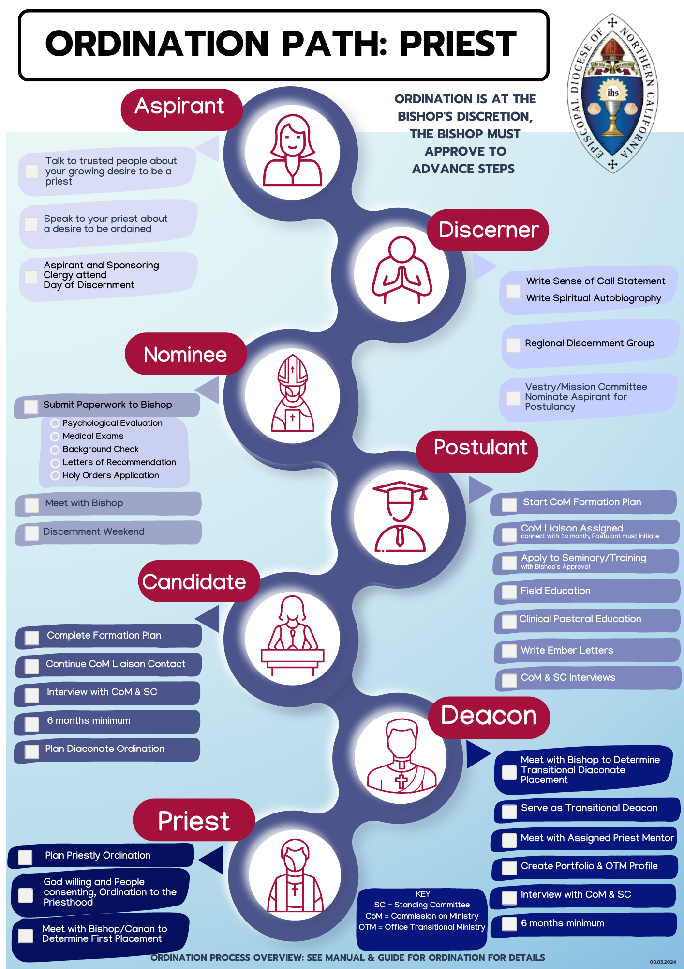

REGIONAL DISCERNMENT GROUP
SUGGESTED MEETING AGENDAS

Sessions:

- “Initial Organization and Training Review” (Dean and RDG Team)
  - A brief period of quiet, an opening prayer and an optional Bible study or meditation.
  - Information and training areas to review and discuss:
    - The overall ordination process
    - The role of the RDG Team in discerning a call to ordained ministry
    - The Deanery Discernment Committee meeting agenda
    - The Discernment Process (a discussion)
    - Priest vs. Deacon – what to look for
    - Lay Ministry and Oblate/3rd Order – what to look for
  - Creation of the RDG’s Organization (RDG)
  - How did it go? How did we work together? What could be done better?
  - Closing prayer
- “Introductions and Spiritual Journey” (RDG Team and Discerner)
  - A brief period of quiet, an opening prayer and an optional Bible study or meditation
  - Emphasize that everything that happens in the meetings will be held in the strictest confidence
  - Introduce yourselves—including the discerner—taking about at least 5 minutes each. Have the discerner share some things about the discerner’s life, work, things that are important to the discerner, the discerner’s relationship with the church and to God. The RDG members should also share their experiences with discernment, if any, and why this type of ministry is important to them
Has the discerner ever wanted to be a priest of a deacon? Has the discerner served on a discernment committee before for a rector or for someone seeking Holy Orders?
  - The remaining time should be spent listening to discerner’s spiritual journey. It is important to work hard to set the tone of the meetings. All team members should actively participate. Listen and offer supporting comments and questions of clarification. Humor is encouraged. Remember don’t offer solutions or suggestions and “no why didn’t you?”
  - Remember, the meeting is open to move where it wants and, with the Holy Spirit’s help, needs to. If the discerner says something that you are curious about or interested in, have the discerner explain. “Tell me more about… or that interests me tell me why you think you felt that way?”

  - Remember any question is a good question as long it is as honest and sincere
  - Discuss meeting times and places, necessary absences and whatever else that seems important to team
  - How did the meeting go? How did we work together? What could be done better?
  - A closing prayer

- “Spiritual Life and Prayer” (RDG Team and Discerner)
  - A brief period of quiet, an opening prayer and an optional Bible study or meditation
  - Discuss the nature and regularity of the discerner’s prayer life
  - Discuss whether they are currently in Spiritual Direction
  - Discuss the discerner’s understanding of spirituality within the Christian context
  - Discuss the discerner’s relationship with Christ
  - Discuss the place of the Eucharist in the discerner’s spiritual life
  - Discuss other issues or questions regarding spiritual and prayer life
  - Discuss the place of scripture in the discerner’s spiritual life
  - Close the discussion with some supportive comments about the discerner’s relationship with God. What did you appreciate about what was discussed?
  - How did the meeting go? Did we work together in a good way? What could be done better?
  - Closing prayer

- “Call to Ministry - Inward and Outward Aspects” (RDG Team and Discerner)
  - A brief period of quiet, an opening prayer and an optional Bible study or meditation
  - Have the discerner read aloud the Ordination as a Deacon Vows and the Ordination of a Priest Vows in Appendix B (BCP pages 543 and 531)
  - Discuss the difference of the two orders and where the discerner sees themselves in the vows
  - The discerners understanding of the theology of the order to which they feel called. Discuss the specific ways they fit the call of that order
  - The discerner’s understanding of the servant nature that order and where they see themselves in it
  - The discerner’s understanding of the sacramental nature of that order and where they see themselves in it
  - The liturgical role of that order during the celebration of the Eucharist and where they see themselves in it
  - Close the discussion with some supportive comments about the positive outward aspects of the discerner’s call. What did you appreciate about what was discussed?
  - How did the meeting go? Did we work together in a good way? What could be done better?
  - Closing prayer.

- “Family Life and Self Care” (RDG Team and Discerner)
  - A brief period of quiet, an opening prayer and an optional Bible study or meditation
  - The discerner’s support system in and outside of family
  - Role of a Spiritual Advisor/Director
  - Financial Considerations - are they well thought out?
  - Level of spouse/family support
  - Past and present self-care strategies
  - Other issues or concerns regarding family life and self-care
  - Close the discussion with some supportive comments about the positive outward aspects of the discerner’s call. What did you appreciate about what was discussed?

  - How did the meeting go? Did we work together in a good way? What could be done better?
  - Closing prayer

- “Leadership and Ecclesiology” (Theology of the Church) (RDG Team and Discerner)
  - A brief period of quiet, an opening prayer and an optional Bible study or meditation
  - The discerner’s understanding or model of the church in the present – how the model might change in the future
  - What is your leadership style and how did you develop it? What was your first leadership role and how did it go? How has your leadership style changed, if at all, over the years?
  - Issues of authority and discipline inside/outside the Church
  - How do you deal with conflict, particularly in interpersonal conflicting relationships?
  - What do you do if people don’t agree with you and won’t follow your ideas?
  - Understanding the relationship between bishop and clergy
  - Understanding of own leadership style – can give examples from past experience

  - Can describe “growing edges” regarding leadership abilities
  - Can describe strategies they might use in a hypothetical situation
  - Other issues or concerns regarding leadership and ecclesiology
  - Close the discussion with some supportive comments about the positive outward aspects of the discerner’s call. What did you appreciate about what was discussed?
  - How did the meeting go? Did we work together in a good way? What could be done better?
  - Closing prayer

- “Academics and Intellectual Life” (RDG Team and Discerner)

  - A brief period of quiet and an opening prayer and an optional Bible or meditation
  - What does the discerner understand as their ability and interest in teaching the faith
  - What kind of formal and/or disciplined course of study has the discerner engaged in related to faith?
  - What is the discerner’s awareness and understanding of diocesan requirements for educational preparation for ordination (Further education)
  - What other academic history has the discerner had, and what does the discerner see as their academic strengths and weaknesses
  - Interest and ability to meet academic requirements for ordained ministry
  - Other issues or concerns regarding academic and intellectual life

  - Close the discussion with some supportive comments about the positive outward aspects of the discerner’s call. What did you appreciate about what was discussed?

  - How did the meeting go? Did we work together in a good way? What could be done better?

  - Closing Prayer.

8) Preliminary Drafting of RDG Report (RDG Team)
When the RDG Team agrees that there has been sufficient time and opportunity to explore all pertinent issues with the discerner—and if the discerner continues to sense a call to ordained ministry—the team should reach a clear understanding of their collective response.
The team then completes the PDF of the RDG Report. Each member must read and e-sign the bottom of the report before it is submitted to Jacqi Seppi at jacqi@norcalepiscopal.org.
Possible Recommendations:
- Recommend Continuing to Discernment Weekend: The team affirms that, after thorough exploration, the discerner understands the process and requirements for ordination, has tested the call, and may indeed have a call to ordained ministry.
- Note Lack of Consensus: If the team does not reach consensus, this should be clearly stated in the report. Accurately describe each member’s perspective.
- Recommend Further Discernment: The team affirms the discerner may have a call but recommends additional time, prayer, and discernment before proceeding further.
- Do Not Recommend at This Time: The team does not recommend the discerner continue exploration of a call to ordained ministry.
- Encourage Lay Ministry: The team recognizes the discerner’s gifts for ministry and encourages them to pursue and explore lay ministry more deeply.
Preparations (suggested)
  - Find a comfortable and quiet place where you won’t be interrupted and spend some time with God. Ask God to guide your recollections and reflections.
  - Read all of the notes for each session and spend some time in reflection on each and how each relates to the whole.

Review previous sessions
    - What have been the discerner’s attitude, involvement and response to the process?
    - Has the discerner been open and willing to share her ideas and thoughts?
    - Have you seen any signs of spiritual growth during the sessions?
    - What areas have been identified as needing some work?
    - What has been each of the team member’s response so far to the discerner’s discerned call to ordain ministry?
    - Have you identified any evidence that may suggest that ordination may be a way to find identity rather than to express ministry, more for the “self” than for the Church?
    - Finish the discussion with a closing prayer and a request for the Holy Spirit to continue to be with the team and the discerner.
    - Some questions to consider:
      - Does the discerner have a good understanding of the nature and demands of the ministry to which they believe they are called?
      - Does the discerner have the personality and skills appropriate for the order to which they feel called?
      - What are the discerner’s strengths for this ministry?
      - Do you see any problem that might make ordination inappropriate for the discerner?

      - Can you see the discerner as your deacon or priest?
      - To which order does the discerner feel called? To which order do you believe the discerner is called? Why?
    - When you are ready, review the suggested RDG Report Outline below. Take your time with each question. Pay attention to your comments realizing they may affect both the discerner and the Church in some way. After you have written your response to the questions, reflect on the discerner and the members on the team. Give thanks for all the gifts they have given you over the past three months or so.
    - Send your responses to the member of the team that has agreed to draft the final report.

Prepare the RDG Report
    - Identify a member of the team willing to compile the team members responses into a first draft of the RDG Report following the suggested format.
    - The final report must recommend the discerner continue the process of discernment toward ordained ministry as a deacon or a priest or pursue a particular ministry in lay leadership e.g. lay preaching, evangelist, catechist. No other recommendation can be made.
    - Circulate the draft to the team, collect all suggested changes and prepare the final report. If consensus on the recommendation to the Commission on Ministry was not possible, a dissenting report may be prepared and submitted by the descanter.

- “Review of the Final Report” (RDG Team and Discerner)
  - Open with a prayer.
  - The RDG Team shares their final recommendation with the discerner, supporting it with examples.
  - If it differs from a recommendation to continue with the process of Holy Orders, significant justification for the recommendation must be supplied.

OUTLINE OF THE RDG REPORT TO THE RECTOR/VICAR/PRIEST-IN-CHARGE AND THE VESTRY/MISSION COMMITTEE AND SHOULD INCLUDE:

- Date
- Name of discerner
- Names of RDG members
- Congregations of the RDG members
- Responses to the following:
  - The RDG’s understanding of the discerner’s call to ordained ministry.
  - The RDG’s understanding of the discerner’s spiritual strengths and weaknesses.
  - An assessment of the discerner’s intellectual ability to pursue graduate level studies in theology, scripture, etc.
  - A description of the discerner’s family situation, including how spouse, partner, children, siblings and parents feel about the discerner’s desire for ordination.
  - A description of the discerner’s spiritual history
  - A description of the discerner’s life and ministry in the congregation
  - An assessment of the discerner’s potential for leadership in the church.
  - An assessment of the discerner’s effectiveness in pastoral and/or interpersonal relationships in the congregation.
  - Additional observations that the Rector/Vicar and Vestry/Mission Committee should know about.
  - The RDG’s formal recommendation for the discerner at this point in time.
  - Signatures of all members.

- The RDG report will be sent to the Bishop along with the Vestry/Mission Committee endorsement, should that body decide to endorse the discerner.

Dear Discerner,
Grace and peace to you in this next chapter of your discernment journey. It has been a joy to walk with you through the Regional Discernment Group process. The care, openness, and reflection you brought to this time are signs of a deep and thoughtful vocation—one rooted in your desire to serve God and God’s people.
Now that your RDG process is complete, the next phase involves preparing materials for Discernment Weekend. This can feel like a lot, but please remember you do not have to complete these steps one at a time or in any particular order. Many of them can be done simultaneously, and the Diocesan Ordination Coordinator, Jacqi Seppi, jacqi@norcalepiscopal.org, 916-442-6918 ext. 213 is here to help guide you along the way.
Below is a list of items you’ll need to begin working on. Forms will come from the diocesan office.
- Letter of Acceptance – Write to the Bishop formally accepting your Vestry’s nomination for Postulancy
- Authorization and Release Form – This allows the required psychiatric/psychological assessment.
- Background Check – Conducted by Oxford Document Management Company and initiated by the Bishop’s Office.
- Medical Exam Form – To be completed by your physician.
- Psychological Evaluation Forms – Includes the Behavioral Screening Questionnaire and Life History Questionnaire.
- Payment Invoice – Your congregation will pay for the evaluation and background check.
- Application for Holy Orders – The formal diocesan application.
- Personal Data Sheet
- Six Letters of Recommendation – Including one from your rector or clergy person in charge.
- Current Resume
- Wallet-size Photo (High Resolution)
- Proof of Baptism and Confirmation
- Official Transcripts – From college and seminary, if applicable.
Each of these steps helps the Bishop, Commission on Ministry, and Standing Committee get a fuller picture of who you are and how God may be calling you. Take it one step at a time, breathe deeply, and trust that the Holy Spirit continues to guide your path.
Please stay in close contact with the Diocesan Ordination Coordinator as you gather these materials. Jacqi Seppi can help you track your progress and answer any questions that arise.
Thank you again for your faithfulness and dedication. The Church rejoices in your willingness to listen for God’s call. May you find joy and peace as you take these next steps.
With prayers and gratitude,
Commission on Ministry
Episcopal Diocese of Northern California

APPENDIX A

BEST PRACTICES FOR A DISCERNMENT PROCESS1

  - Prayerful listening.
  - Open mind and open heart.
  - Confidentiality.
  - Consider this work a high priority and a gift of your time and talents to the Church.
  - Trust in the Holy Spirit to guide the process.
  - Open in prayer and close in prayer.
  - Be respectful and accepting of one another’s views and thoughts.
  - Be compassionate and caring of all involved in this process.
  - Be willing to be influenced by others, not locked into your own opinion
  - Listen and guide rather than give advice.
  - Raise caring and probing questions to help the discerner move toward a sense of clearness and a deeper comprehension of an issue in relation to God’s call.
  - This process is focused on the individual’s discernment and assisting
him/her through this process. Questions that satisfy your curiosity are focused on you, not on the individual, and are not appropriate.

1 Developed by Lisa Sargent and Mary Davy.

APPENDIX B
BCP ORDINATION VOWS

DEACON ORDINATION VOWS

The Bishop addresses the ordinand as follows

My brother, every Christian is called to follow Jesus Christ, serving God the Father, through the power of the Holy Spirit. God now calls you to a special ministry of servanthood directly under your bishop. In the name of Jesus Christ, you are to serve all people, particularly the poor, the weak, the sick, and the lonely. As a deacon in the Church, you are to study the Holy Scriptures, to seek nourishment from them, and to model your life upon them. You are to make Christ and his redemptive love known, by your word and example, to those among whom you live, and work, and worship. You are to interpret to the Church the needs, concerns, and hopes of the world. You are to assist the bishop and priests in public worship and in the ministration of God’s Word and Sacraments, and you are to carry out other duties assigned to you from time to time. At all times, your life and teaching are to show Christ’s people that in serving the helpless they are serving Christ himself.

My brother, do you believe that you are truly called by God and his Church to the life and work of a deacon?

Answer I believe I am so called.

Bishop Do you now in the presence of the Church commit yourself to this trust and responsibility?

Answer I do.

Bishop Will you be guided by the pastoral direction and leadership of your bishop?

Answer I will.

Bishop Will you be faithful in prayer, and in the reading and study of the Holy Scriptures?

Answer I will.

Bishop Will you look for Christ in all others, being ready to help and serve those in need?

Answer I will.

Bishop Will you do your best to pattern your life [and that of your family, or household, or community] in accordance with the teachings of Christ, so that you may be a wholesome example to all people?

Answer I will.

Bishop Will you in all things seek not your glory but the glory of the Lord Christ?

Answer I will.

Bishop May the Lord by his grace uphold you in the service he lays upon you.

Answer Amen.

Church Publishing. Book of Common Prayer Basic Pew Edition: Red Hardcover (pp. 543-544). (Function). Kindle Edition.

PRIEST ORDINATION VOWS

The Examination
All are seated except the ordinand, who stands before the Bishop.

The Bishop addresses the ordinand as follows

My brother, the Church is the family of God, the body of Christ, and the temple of the Holy Spirit. All baptized people are called to make Christ known as Savior and Lord, and to share in the renewing of his world. Now you are called to work as a pastor, priest, and teacher, together with your bishop and fellow presbyters, and to take your share in the councils of the Church. As a priest, it will be your task to proclaim by word and deed the Gospel of Jesus Christ, and to fashion your life in accordance with its precepts. You are to love and serve the people among whom you work, caring alike for young and old, strong and weak, rich and poor. You are to preach, to declare God’s forgiveness to penitent sinners, to pronounce God’s blessing, to share in the administration of Holy Baptism and in the celebration of the mysteries of Christ’s Body and Blood, and to perform the other ministrations entrusted to you. In all that you do, you are to nourish Christ’s people from the riches of his grace, and strengthen them to glorify God in this life and in the life to come. My brother, do you believe that you are truly called by God and his Church to this priesthood?

Answer I believe I am so called.

Bishop Do you now in the presence of the Church commit yourself to this trust and responsibility?

Answer I do.

Bishop Will you respect and be guided by the pastoral direction and leadership of your bishop?

Answer I will.

Bishop Will you be diligent in the reading and study of the Holy Scriptures, and in seeking the knowledge of such things as may make you a stronger and more able minister of Christ?

Answer I will.

Bishop Will you endeavor so to minister the Word of God and the sacraments of the New Covenant, that the reconciling love of Christ may be known and received?

Answer I will.

Bishop Will you undertake to be a faithful pastor to all whom you are called to serve, laboring together with them and with your fellow ministers to build up the family of God?

Answer I will.

Bishop Will you do your best to pattern your life [and that of your family, or household, or community] in accordance with the teachings of Christ, so that you may be a wholesome example to your people?

Answer I will.

Bishop Will you persevere in prayer, both in public and in private, asking God’s grace, both for yourself and for others, offering all your labors to God, through the mediation of Jesus Christ, and in the sanctification of the Holy Spirit?

Answer I will.

Bishop May the Lord who has given you the will to do these things give you the grace and power to perform them.

Answer Amen.

Church Publishing. Book of Common Prayer Basic Pew Edition: Red Hardcover (pp. 532-533). (Function). Kindle Edition.

APPENDIX C

Regional Discernment Group Authorized Trainer

The Rev. Dr. Anny Genato
pastoranny@staugustineepiscopal.com
323-434-4067

