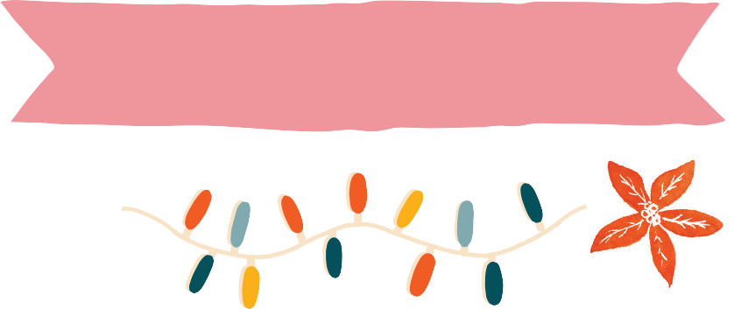

E.E. CUMMINGS
AND THE JOYFUL POETRY OF ADVENT

November 30 – Hope

“i thank You God most for this amazing”
(read by the poet: https://youtu.be/axH9A28CTjw )

i thank You God for most this amazing
day:for the leaping greenly spirits of trees
and a blue true dream of sky;and for everything
which is natural which is infinite which is yes

(i who have died am alive again today,
and this is the sun’s birthday;this is the birth
day of life and of love and wings:and of the gay
great happening illimitably earth)

how should tasting touching hearing seeing
breathing any—lifted from the no
of all nothing—human merely being
doubt unimaginable You?

(now the ears of my ears awake and
now the eyes of my eyes are opened)

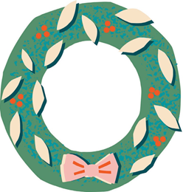

December 7 – Peace

“the glory is fallen out of”

the glory is fallen out of
the sky the last immortal
leaf
is

dead and the gold
year
a formal spasm
in the

dust
this is the passing of all shining things
therefore we also
blandly

into receptive
earth,O let
us
descend

take
shimmering wind
these fragile splendors from
us crumple them hide
them in they breath drive
them in nothingness
for we
would sleep

this is the passing of all shining things
no lingering no backward-
wondering be unto
us O

soul,but straight
glad feet fearruining
and glorygirded
faces

lead us
into the
serious
steep

darkness

December 14 - Joy

“Christmas Poem”

from spiralling ecstatically this

proud nowhere of earth’s most prodigious night
blossoms a newborn babe:around him,eyes
— gifted with ever keener appetite
than mere unmiracle can quite appease —
humbly in their imagined bodies kneel
(over time space doom dream while floats the whole

perhapsless mystery of paradise)

mind without soul may blast some universe
to might have been,and stop ten thousand stars
but not one heartbeat of this child;nor shall
even prevail a million questionings
against the silence of his mother’s smile

— whose only secret all creation sings



December 21 - Love

“love is more thicker than forget” and “[i carry your heart with me(i carry it in]”

“love is more thicker than forget”

love is more thicker than forget
more thinner than recall
more seldom than a wave is wet
more frequent than to fail

it is most mad and moonly
and less it shall unbe
than all the sea which only
is deeper than the sea

love is less always than to win
less never than alive
less bigger than the least begin
less littler than forgive

it is most sane and sunly
and more it cannot die
than all the sky which only
is higher than the sky

“[i carry your heart with me(i carry it in]”

i carry your heart with me(i carry it in
my heart)i am never without it(anywhere
i go you go,my dear;and whatever is done
by only me is your doing,my darling)
i fear

no fate(for you are my fate,my sweet)i want
no world(for beautiful you are my world,my true)
and it’s you are whatever a moon has always meant
and whatever a sun will always sing is you

here is the deepest secret nobody knows
(here is the root of the root and the bud of the bud
and the sky of the sky of a tree called life;which grows
higher than soul can hope or mind can hide)
and this is the wonder that’s keeping the stars apart

i carry your heart(i carry it in my heart)

